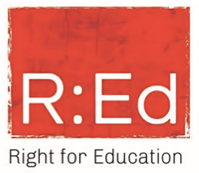
CERTIFICATE

OF ATTENDANCE
Larry Amariaji
has attended in the online training:
„Medical Device Essentials“

conducted by SternMed GmbH in collaboration
with R:Ed - Right for Education Africa.
This training is part of a collaborative educational initiative designed to empower healthcare professionals with practical
knowledge for the safe, efficient, and sustainable use of medical devices. Conducted over a three-month period, the program
covered a range of devices including medical imaging systems, intensive care units, and operating room equipment.
Delivered through online live expert sessions, the training provided an introduction to the basic functions and technological
fundamentals of medical devices. It reflects our commitment to responsible healthcare by supporting knowledge-sharing and
encouraging informed engagement with medical technology.
This is a computer-generated document. No signature is required. Issued by SternMed GmbH.
SternMed has no responsibility for the training performance of the participant
For third-party validation please contact: support@sternmed.de
Certificate Number:

SM-RED-2025-037
Date of Issue:
2025

